Digital Geometry Processing - 236329

Homework 3

316948694 201631348

1. Implemented in method 'visualize_vec' of class 'MeshHandle'.
2. Implemented in methods 'calc_grad', 'calc_div' and 'calc_laplas' of class 'MeshHandle'.

Gradient of sphere height: Divergence of gradient field:

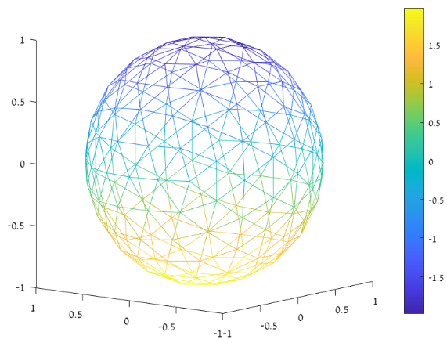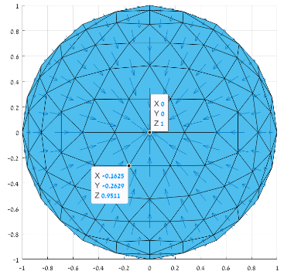

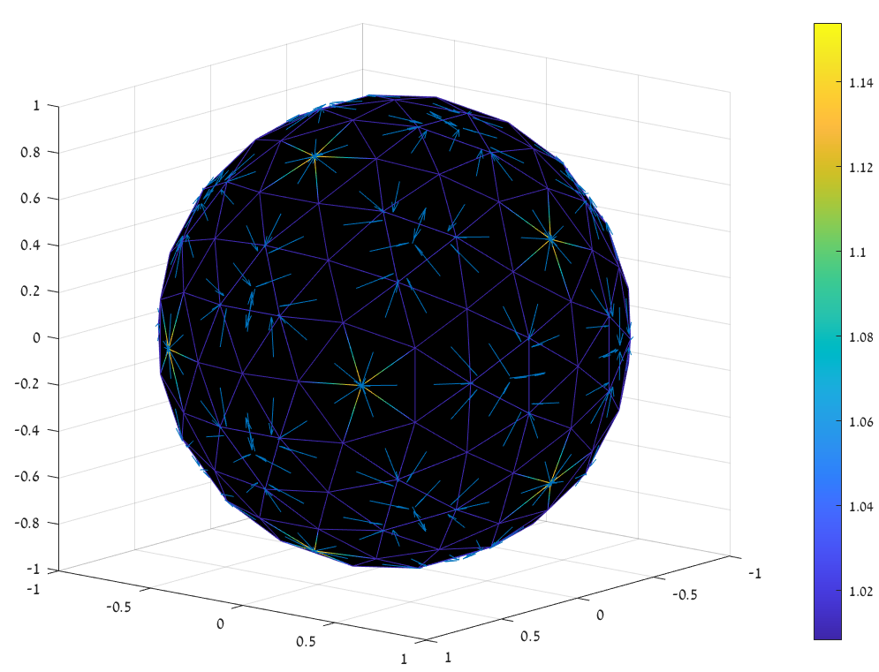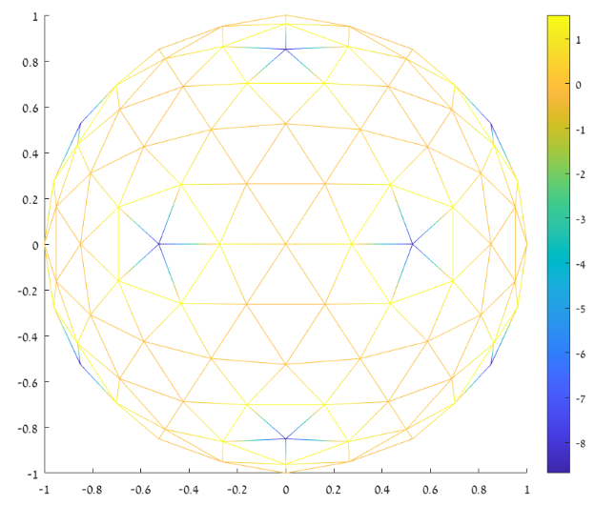Gradient of gaussian curvature: Divergence of gradient field:

Gradient of oloid height: Divergence of gradient field:

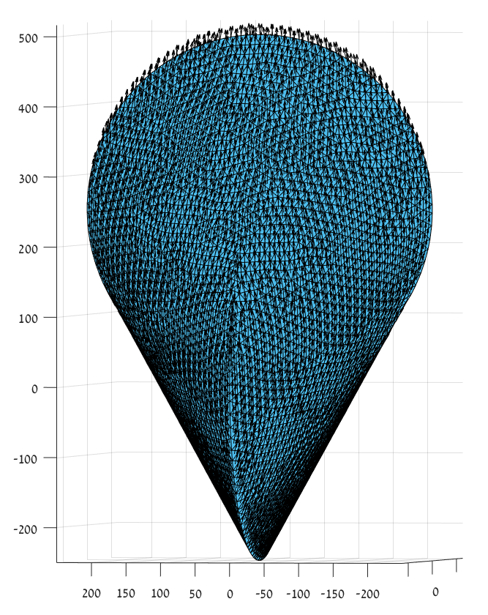

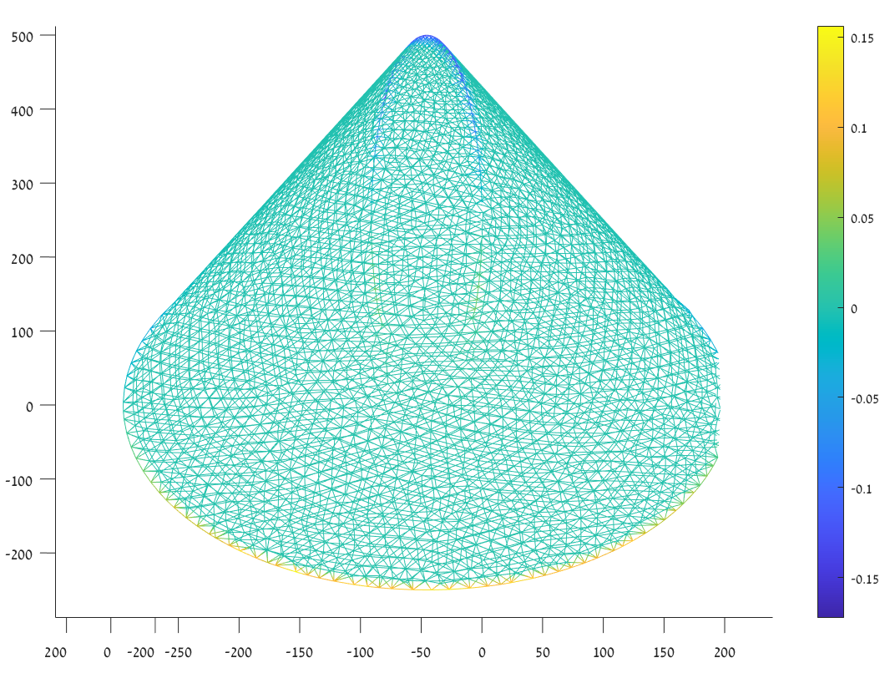

1. Implemented in method 'calc_laplas_cot' of class 'MeshHandle'. Comparison between the two Laplace calculations produces negligible differences (that occur due to numerical inaccuracies).
2. The quad mesh, with a linear function upon it can be seen in the following figure

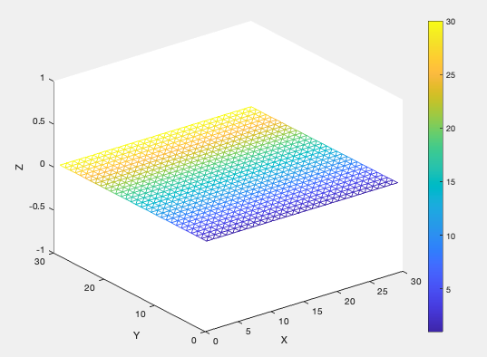

Computing its cot-Laplacian (the element-wise formula) is depend on a given function, thus cannot be deduced inductively. If the question would aim to the matrix form of the Laplacian operator, one would be able to construct the faces-area matrix (for example, with a constant function, all the areas would be 0.5), the vertex-area matrix (due to the recurrent structure) and the gradient matrix, and compute the operation matrix.

1. Implemented in method 'vertex_normal' of class 'MeshHandle'.

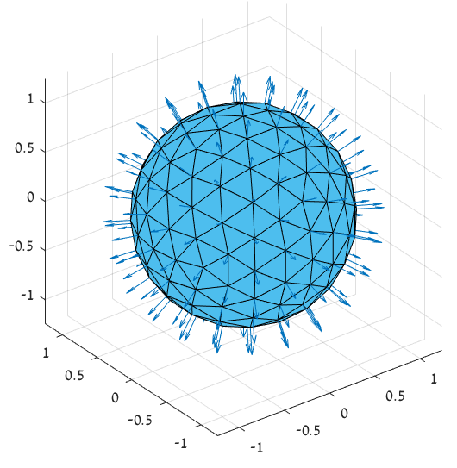Examples:

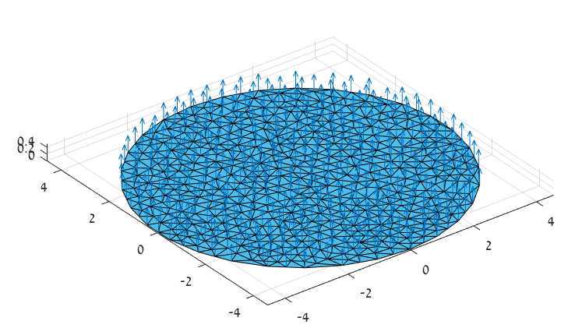

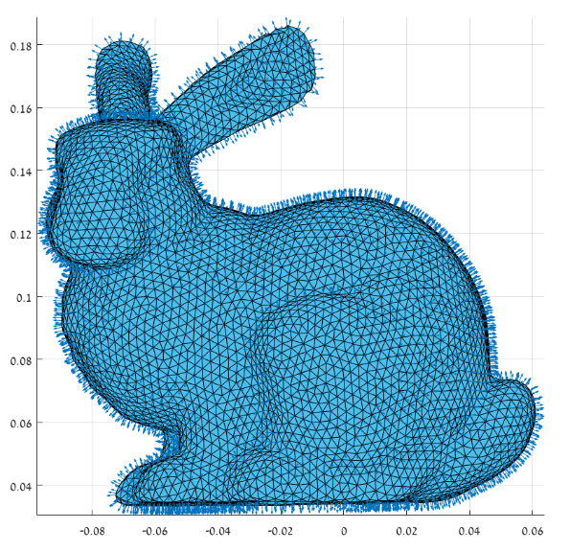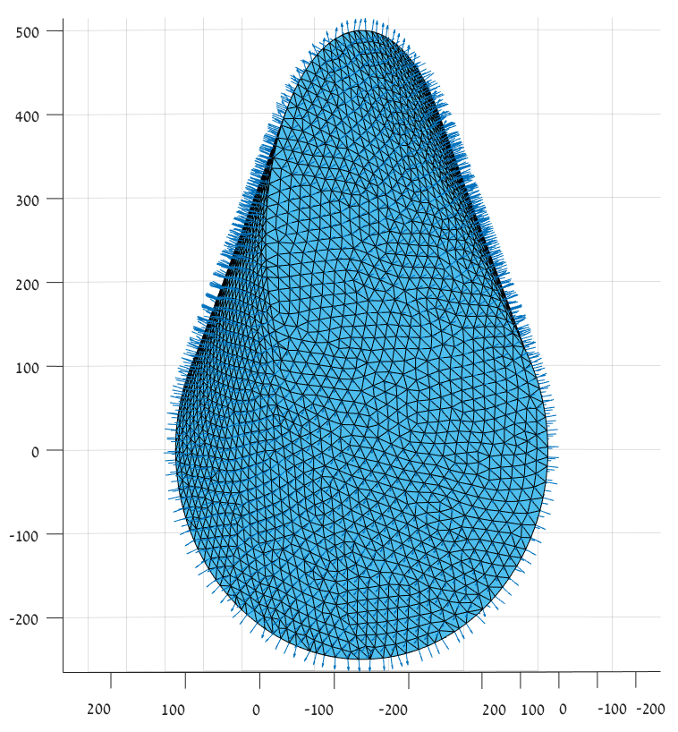

1. Implemented in method 'calc_mean_curv' and 'calc_gauss_curv' of class 'MeshHandle'.

***Gaussian curvature***

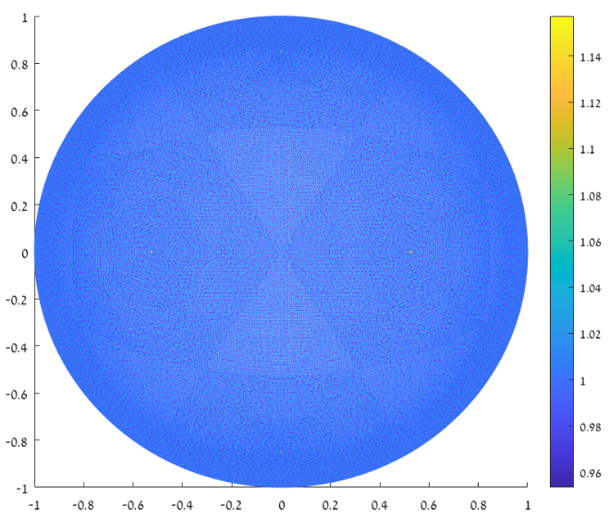

For a dense unit sphere, the gaussian curvature is approximately 1 at all vertices.

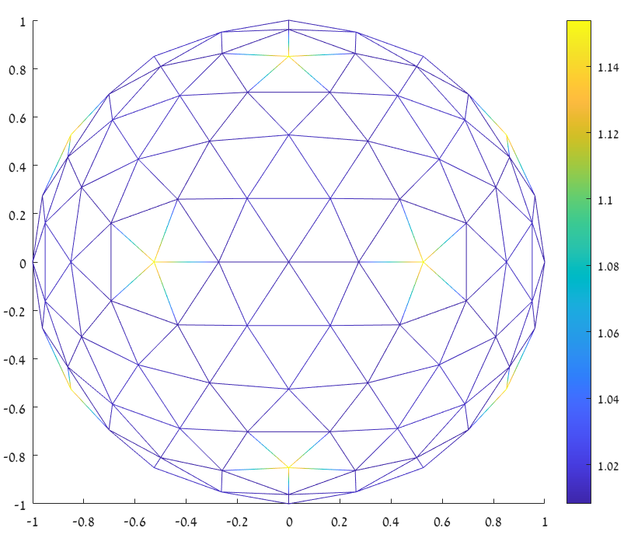

For a less dense unit sphere, whenever the valence is getting lower the curvature is getting higher.

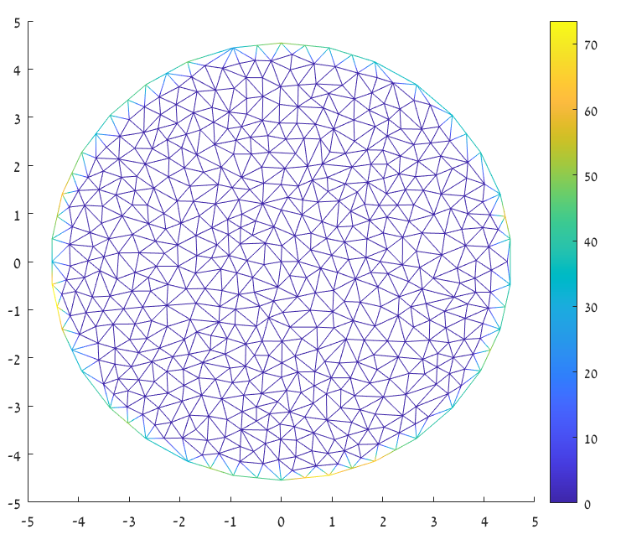

Disk curvature is approximately constant 0 except of the boundary.

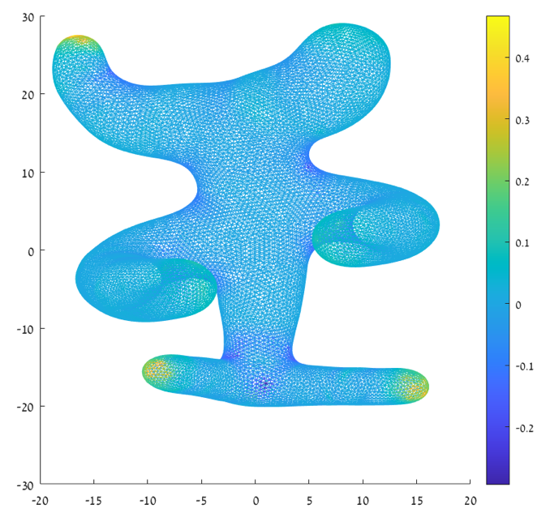

***Mean curvature***

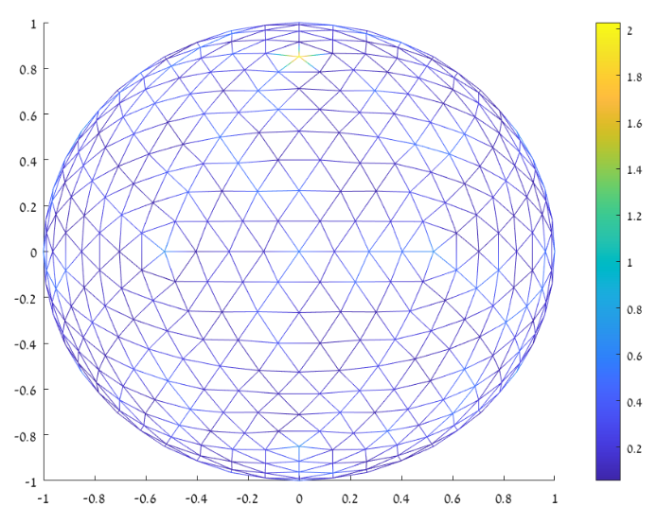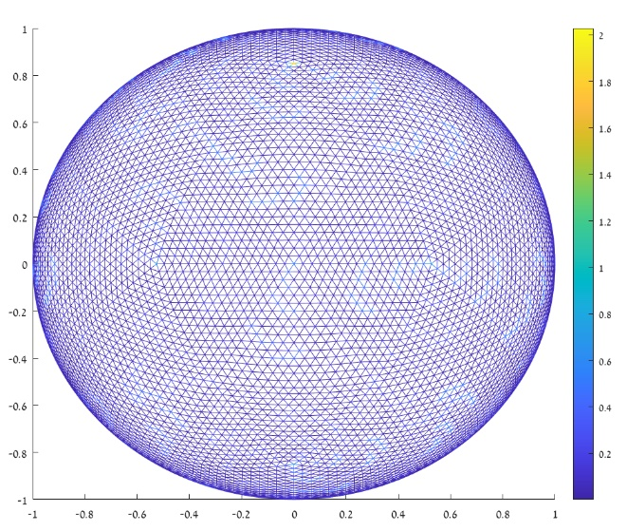

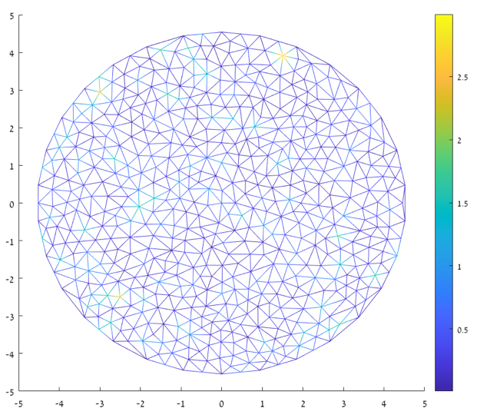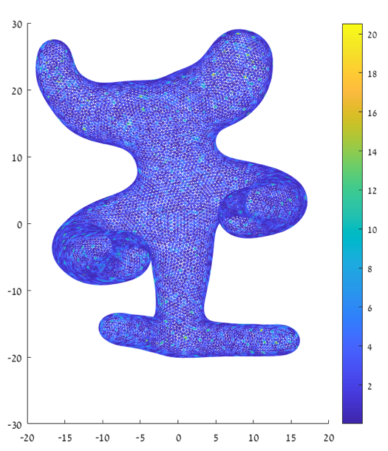

***Analysis***

1. + 2. **\*\*\* Conclusions are at the end \*\*\***

Sphere:

Null –

constant function non-constant function

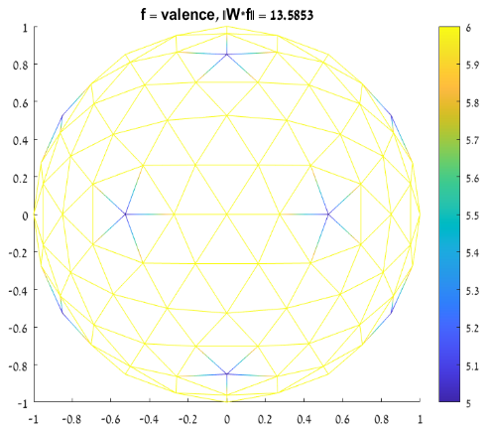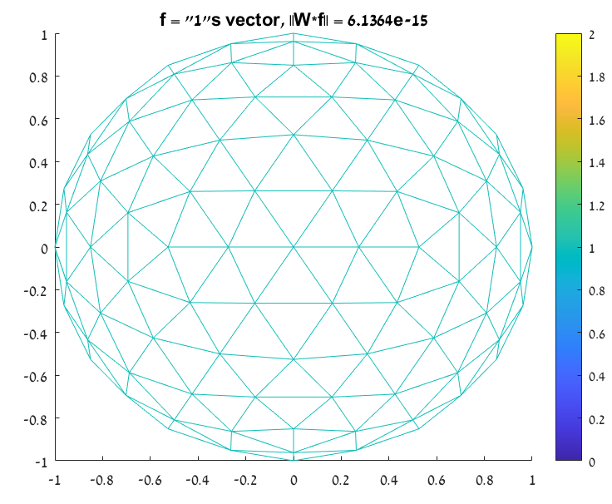

Symmetry –



Localization –

# non-zero elements = 1122 (out of 26244)

# edges = 480

# vertices = 162

* # non-zero elements = 2*# edges + # vertices

Positivity –

W contains non positive elements

Positive semi-definite –

W is positive semi-definite as all it's eigenvalues are positive. Smallest eigenvalue = 8.8914e-17, Largest eigenvalue = 5.3873

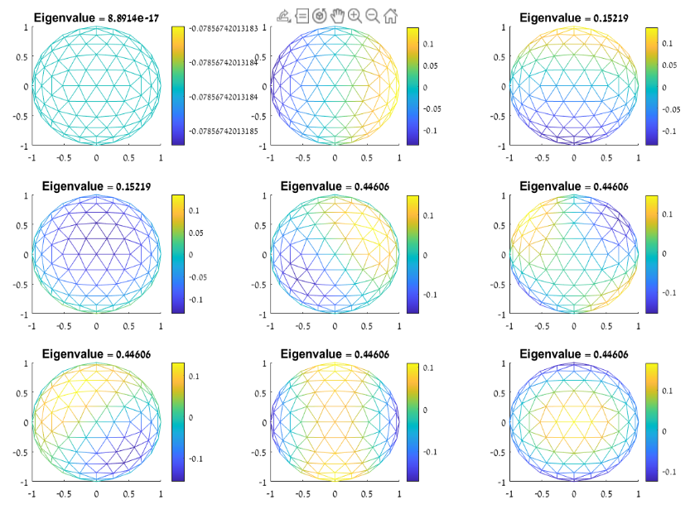Eigenfunctions examples –

Vase:

Null –

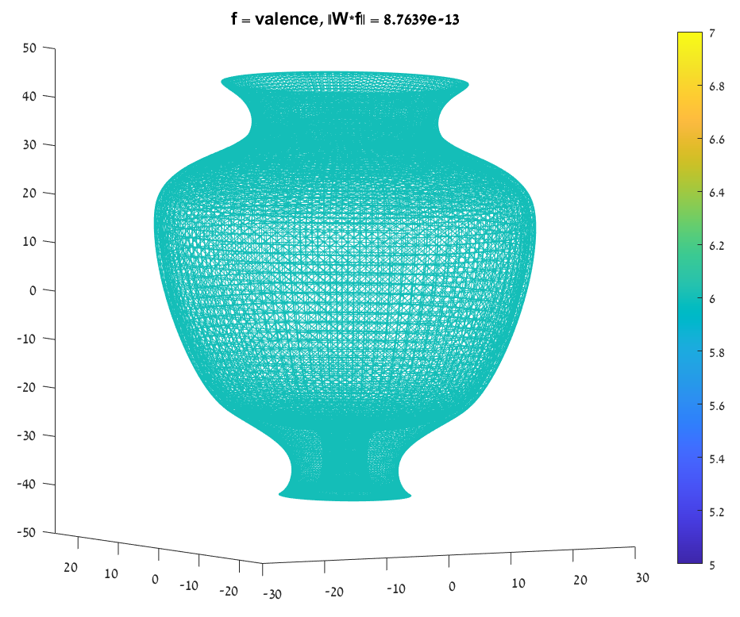constant function non-constant function

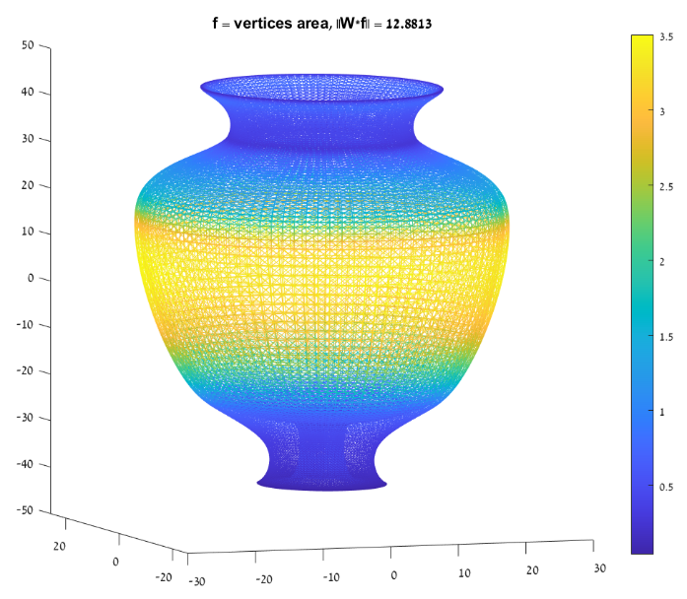Symmetry –



Localization –

# non-zero elements = 153216 (out of 479084544)

# edges = 65664

# vertices = 21888

* # non-zero elements = 2*# edges + # vertices

Positivity –

W contains non positive elements

Positive semi-definite –

W is positive semi-definite as all it's eigenvalues are positive. Smallest eigenvalue = 5.3428e-17, Largest eigenvalue = 14.3993

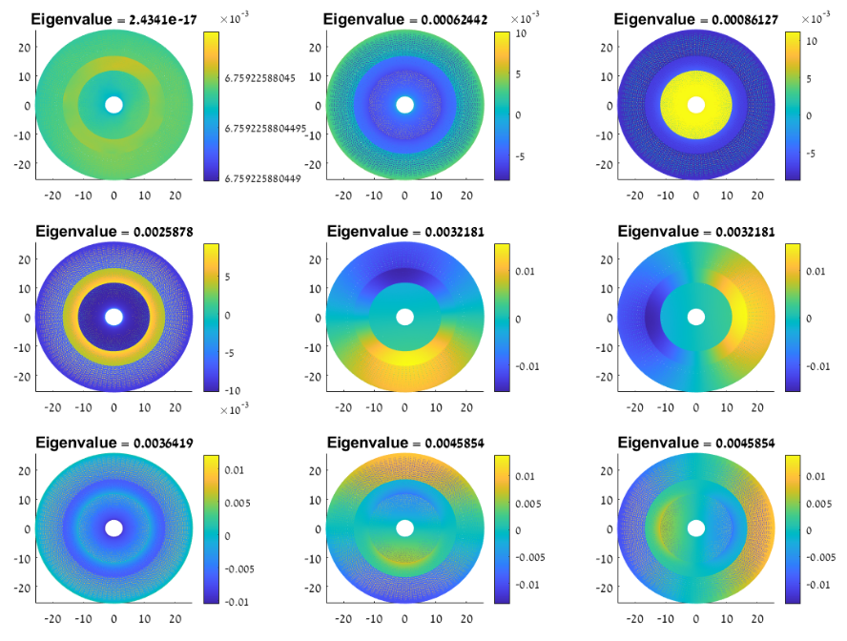Eigenfunctions examples –

Disk:

Null –

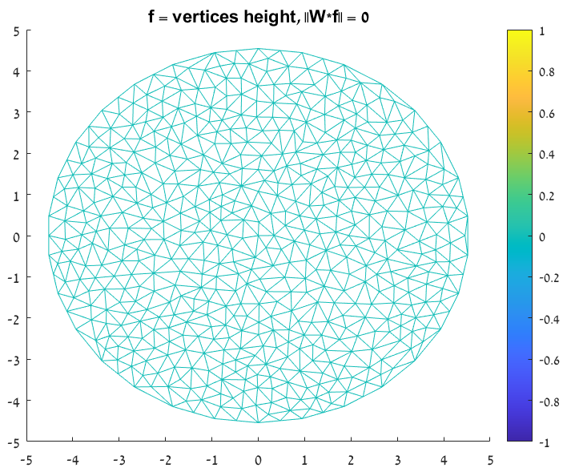constant function non-constant function

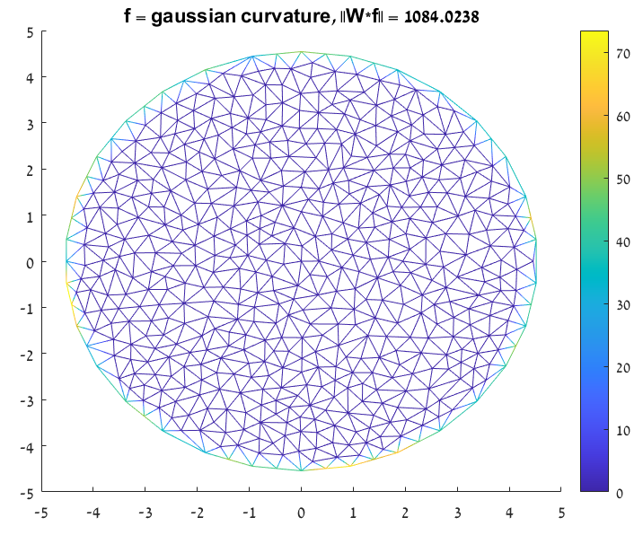

Symmetry –



Localization –

# non-zero elements = 3672 (out of 291600)

# edges = 1566

# vertices = 540

* # non-zero elements = 2*# edges + # vertices

Positivity –

W contains non positive elements

Positive semi-definite –

W is positive semi-definite as all it's eigenvalues are positive. Smallest eigenvalue = 5.3428e-17, Largest eigenvalue = 14.3993

Eigenfunctions examples –

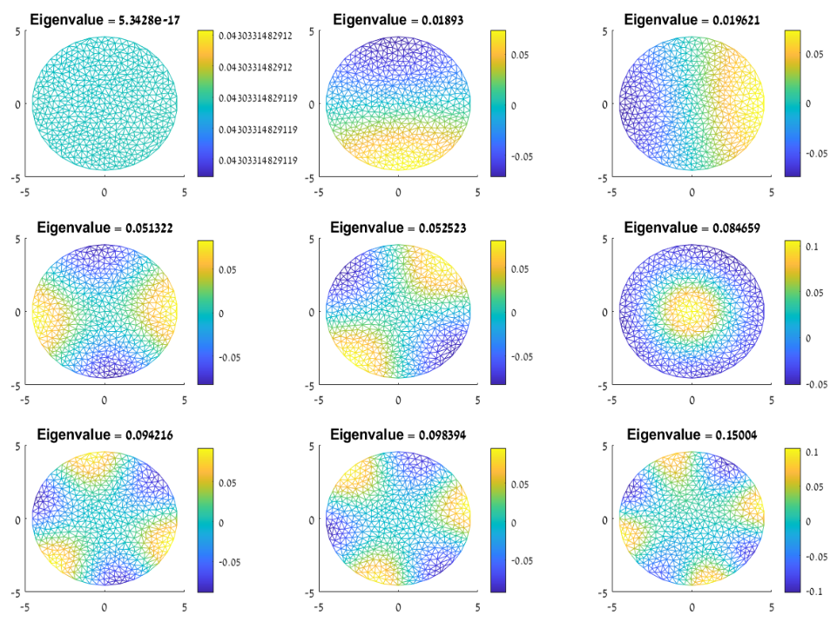

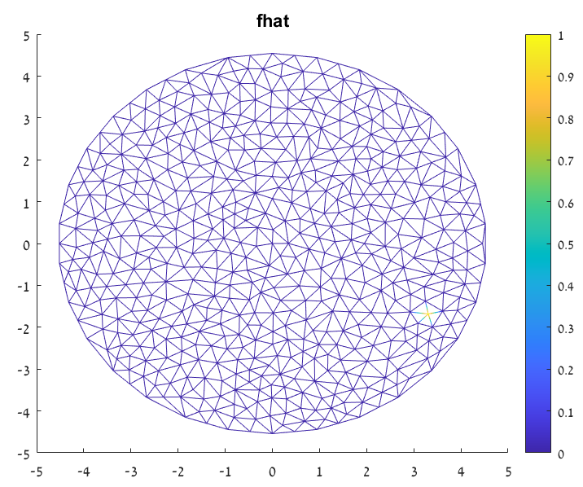 Hat function:

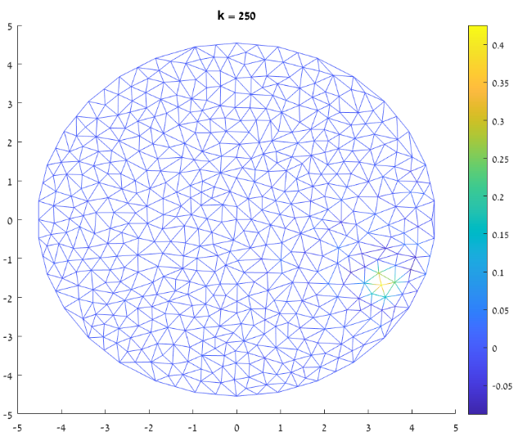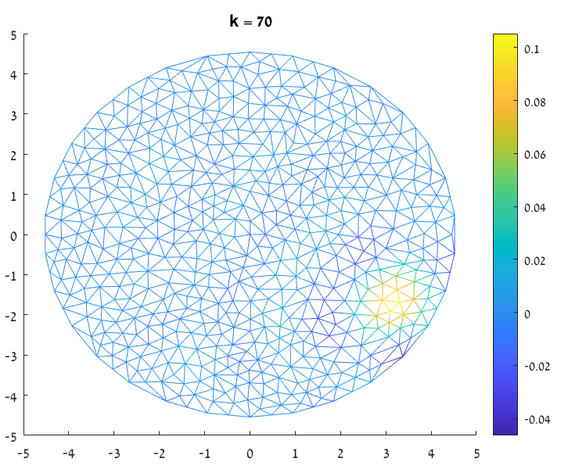 Approximation with 70 eigenvectors: Approximation with 250 eigenvectors:

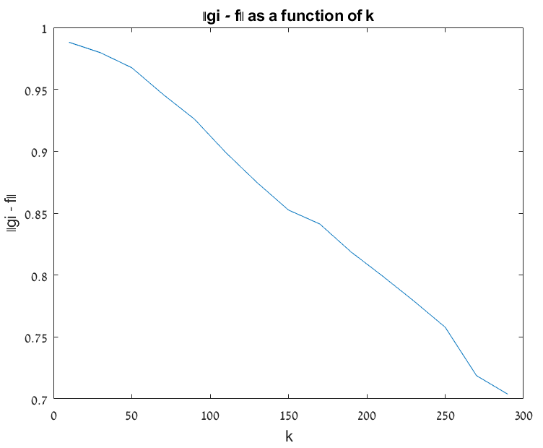Approximation error as a function of k – number of eigenvectors that are used for approximation:

Conclusions:

Null – as expected, for constant function  .

Symmetry – W is a symmetrical matrix. We showed that , where the

Frobenius norm defined as .

Sparse metrix – For all examples, the amount of the non-zero elements is significantly

smaller than the total number of matrix-elements. Also, the following relation is being

held:

# non-zero elements = 2*# edges + # vertices

Positivity – W contains non-positive elements.

Positive semi-definite – As all the eigenvalues of W are positive, W is a positive semi-definite matrix.

Eigenfunction examples – The eigenfunctions seems to look like harmonic components (the first one is constant, and later it contains some peeks and lows).

Function approximation – One can notice from the disk example that for a higher k number, the desired function is better approximated. It can be seen from the snapshots as well as from the graph that describes that approximation error as a function of k.

3. The first 10 spherical harmonics on a sphere mesh:

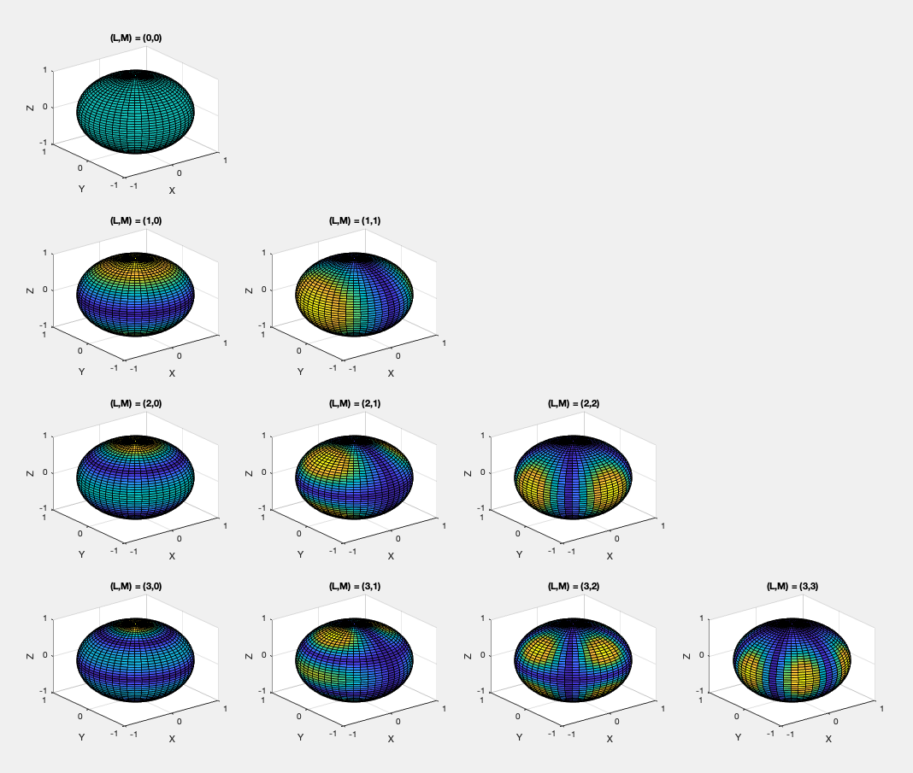

The first 10 eigen vectors on a sphere mesh:

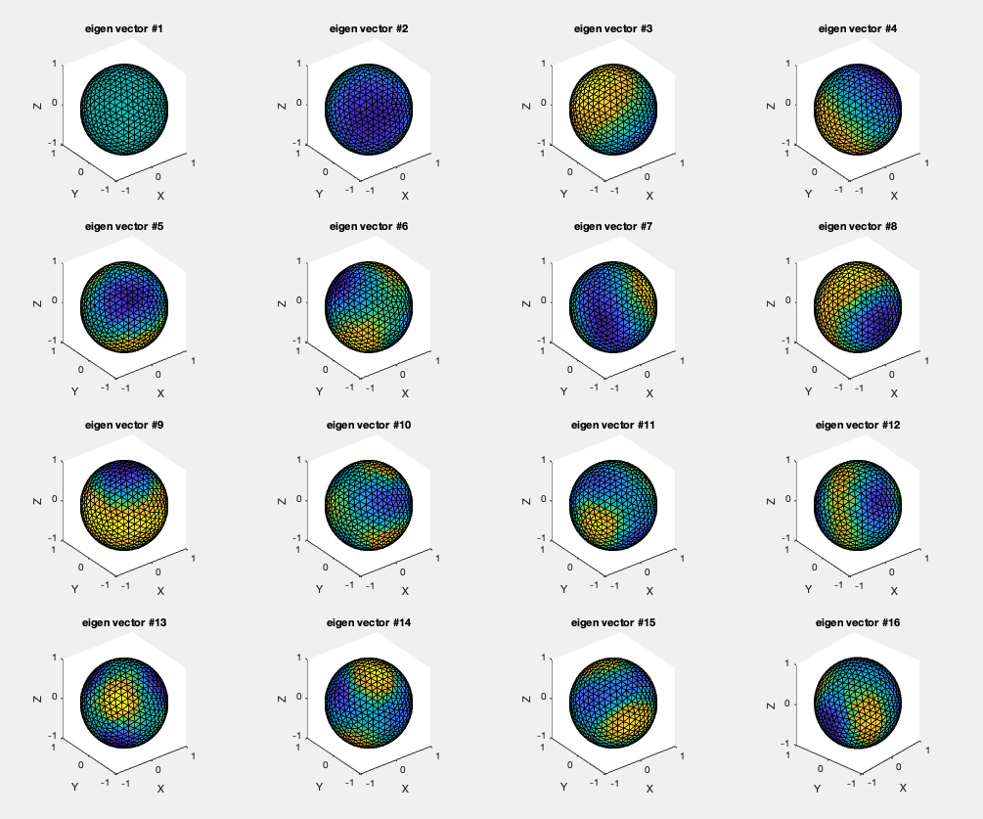

As expected, up to order, there are similar spheres in the above figures.